1. **Customer Segmentation and Profiling**

**Insights:**

* We performed customer segmentation based on purchasing behavior, preferences, and demographics.
* Three distinct customer segments were identified:
  1. **High-Value Customers:** High-frequency shoppers with high monetary contributions.
  2. **Medium-Value Customers:** Moderate-frequency shoppers with moderate monetary contributions.
  3. **Low-Value Customers:** Low-frequency shoppers with low monetary contributions.

Cluster 0:

Customer Profile:

* Average Number of Transactions: 59.27
* Average Total Quantity Purchased: 22,921.12
* Average Total Amount Spent: $35,855.77

Insights:

* Cluster 0 represents a group of highly engaged and frequent customers.
* These customers make a significant number of transactions, indicating loyalty and regular interaction with the online retail platform.
* They have a high total quantity purchased and spend a substantial amount, making them high-value customers.
* Strategies to retain and reward loyalty, such as exclusive offers or loyalty programs, could be effective for this segment.

Cluster 1:

Customer Profile:

* Average Number of Transactions: 4.46
* Average Total Quantity Purchased: 805.09
* Average Total Amount Spent: $1,352.35

Insights:

* Cluster 1 represents a group of infrequent and less engaged customers.
* These customers make a relatively small number of transactions, indicating lower interaction with the platform.
* They have a lower total quantity purchased and spend less compared to other clusters.
* Targeted marketing campaigns to increase engagement and incentivize additional purchases may be beneficial for this segment.

Cluster 2:

Customer Profile:

* Average Number of Transactions: 93.6
* Average Total Quantity Purchased: 96,858.4
* Average Total Amount Spent: $195,941.55

Insights:

* Cluster 2 represents a group of extremely high-value customers.
* These customers have a very high average total quantity purchased and spend a substantial amount, making them the most valuable segment.
* Strategies to further cater to their preferences, personalized offerings, and exclusive services could enhance their satisfaction and potentially increase their spending.

1. **Product Recommendation System**

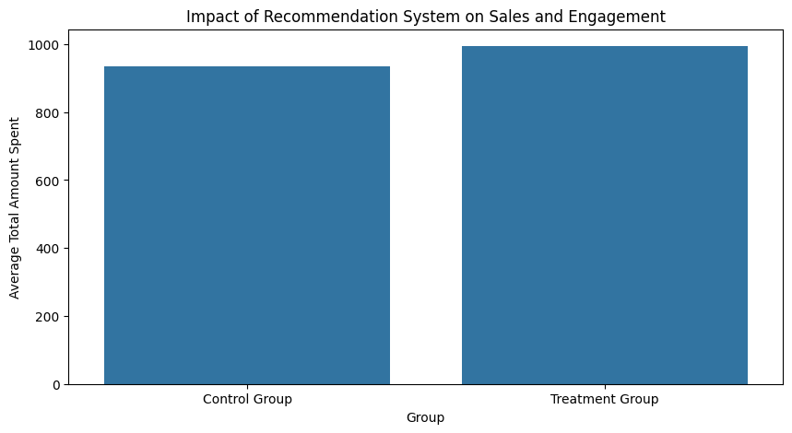

**Insights:**

* The bar chart provided compares the average total amount spent by two groups: a Control Group and a Treatment Group.

**Implications for the Product Recommendation System**:

* Increased Sales: The higher average spend in the Treatment Group suggests that the recommendation system may have positively influenced sales. Customers in this group, on average, spent more than those who did not receive recommendations.
* Customer Engagement: While the chart does not directly measure engagement, we can infer that the recommendation system might have increased customer engagement. Higher spend is often a proxy for greater engagement, as personalized recommendations can lead to customers discovering more products they are interested in, thereby spending more time on the site and engaging with the content.

**Recommendations:**

* Continue refining and expanding the recommendation system with machine learning algorithms.
* Monitor user feedback and adjust recommendations to enhance user experience further.
* This visual evidence can be part of a broader evaluation of the recommendation system's effectiveness. If the Treatment Group's higher spend is statistically significant, it supports the argument that the recommendation system is effective at driving higher sales.

**3. Basket Analysis and Cross-Selling Strategies**

**Insights:**

* Basket analysis revealed associations between products frequently purchased together.
* Strong associations were identified, indicating cross-selling opportunities.
* The segmentation aligns with expected customer behavior, providing distinct groups for targeted strategies.

**Recommendations:**

* Implement cross-selling strategies, such as package deals.
* Develop personalized product recommendations based on association rules (see rules below).
* Implement loyalty programs for Cluster 0 to reinforce their engagement.
* Launch targeted marketing campaigns for Cluster 1 to increase their activity.
* Develop exclusive services or personalized offerings for Cluster 2 to capitalize on their high-value status.

**Rule**: If a customer purchases (20712), there's a 61.99% chance they will also purchase (85099B). The lift is 7.68, indicating a strong association. This suggests that (85099B) is a complementary product to (20712).

**Rule**: If a customer purchases (85099B), there's a 25.57% chance they will also purchase (20712). The lift is 7.68, indicating a strong association. This suggests that (20712) is a complementary product to (85099B).

**Rule**: If a customer purchases (20724), there's a 50.48% chance they will also purchase (22356). The lift is 17.60, indicating a strong association. This suggests that (22356) is a complementary product to (20724).

**Rule**: If a customer purchases (22356), there's a 70.26% chance they will also purchase (20724). The lift is 17.60, indicating a strong association. This suggests that (20724) is a complementary product to (22356).

**Rule**: If a customer purchases (20725), there's a 33.61% chance they will also purchase (20726). The lift is 8.55, indicating a strong association. This suggests that (20726) is a complementary product to (20725).

**Cross-Selling Strategies:**

Based on these rules, you can consider the following cross-selling strategies:

* Bundle Offers: Offer a bundle deal for products (20712) and (85099B) to encourage customers to purchase both items together.
* Product Recommendations: Suggest (20712) to customers who have added (85099B) to their cart, and vice versa.
* Package Deals: Create package deals that include both (20724) and (22356) to incentivize customers to buy these complementary products together.
* Product Recommendations: Suggest (22356) to customers who have added (20724) to their cart, and vice versa.
* Combo Offers: Introduce combo offers for customers who are interested in both (20725) and (20726).

*These strategies aim to leverage the identified associations between products and encourage customers to explore and purchase complementary items.*

* 1. **Customer Lifetime Value (CLV) Analysis**

**Insights:**

* CLV was calculated for different customer segments.
* High-value customers had the highest CLV, followed by medium-value and low-value customers.

**Recommendations:**

* High CLV customers could be targeted with loyalty programs and premium offers, while strategies for medium and low CLV customers could focus on increasing frequency and monetary value.
* Tailor Marketing to Recent Customers: Customers with low recency (recent purchases) should be kept engaged with new offers and products to maintain their high CLV.
* Increase Purchase Frequency: For customers with high monetary value but low frequency, strategies could include subscription models, reminders for repurchases, or targeted promotions to encourage more frequent shopping.
* Enhance Avg Revenue Per Order: For customers who shop infrequently but spend a lot when they do, bundling products, cross-selling, and up-selling strategies could be effective.
* Re-engage Lapsed Customers: For customers with high recency numbers (like customer 12346.0 and 12350.0), re-engagement campaigns using special offers or information about new products can be used to bring them back and potentially increase their CLV.

Strategies to Maximize CLV:

Segment Customers:

High-Value Customers (CLV > 5000):

* Targeted Marketing: Launch exclusive campaigns, offering premium products, loyalty rewards, and personalized experiences.
* Upselling: Identify opportunities to upsell high-value products or services based on their previous purchases.

Medium-Value Customers (5000 >= CLV > 2000):

* Targeted Promotions: Design promotions to encourage repeat purchases and increase the average order value.
* Product Bundles: Offer product bundles or packages to maximize revenue from each transaction.

Low-Value Customers (CLV <= 2000):

* Reactivation Campaigns: Implement targeted campaigns with discounts or promotions to re-engage low-value customers.
* Cross-Selling: Introduce cross-selling strategies to recommend complementary products and increase their basket size.

Loyalty Programs:

All Segments:

* Implement or enhance a tiered loyalty program, providing exclusive benefits, early access to sales, and special discounts based on CLV segments.

Personalized Recommendations:

All Segments:

* Leverage customer data to provide personalized product recommendations through emails, website notifications, or mobile apps.
  1. **Time-Series Analysis for Seasonal Trends:**

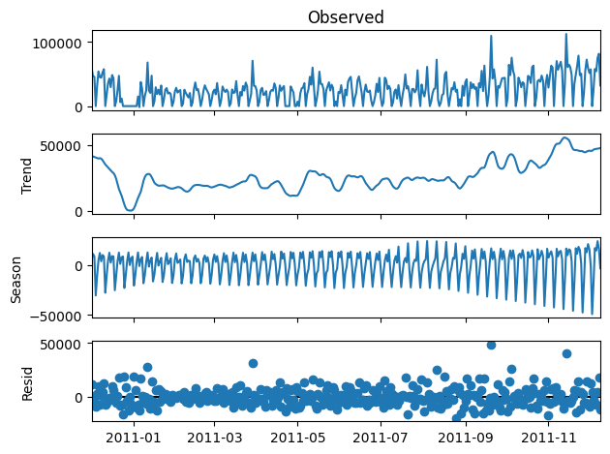

**Insights:**

* Seasonal Peaks: The regular spikes in the observed data and the clear seasonal pattern suggest that there are specific times of the year when sales increase significantly. These could be times when we should stock more inventory to meet the increased demand.
* Trend Growth: The upward trend indicates that overall sales are increasing over time, so we might consider increasing our baseline stock levels to account for this growth.
* Residual Analysis: Residuals should be random and with no pattern. If there are patterns in the residuals, it could suggest that the model is not fully capturing all the seasonal effects or there might be other factors affecting sales.

**Recommendations:**

* Inventory Optimization: Based on the seasonal component, we can plan ahead for inventory needs, ensuring we are well-stocked for the expected peaks and avoiding overstock in the expected lows.
* Marketing and Promotions: Use the knowledge of seasonal trends to plan marketing campaigns and promotions to coincide with peak sales periods.
* Resource Allocation: Allocate more staff and resources during peak times to ensure customer demand is met, and possibly reduce resources during off-peak times to save costs.
* Continuous Monitoring: Keep analyzing the time series as new data comes in to update our models and strategies, ensuring they reflect the most current trends and patterns.

**Conclusion**

Our analysis of the Online Retail dataset has provided valuable insights and actionable recommendations to enhance customer satisfaction, optimize sales processes, maximize CLV, and improve inventory management. By implementing these strategies, our online retail company is well-positioned to achieve its goal of elevating the customer experience and maximizing sales.